**LAB EXPERIMENT – 6**

**Cookie Stealing and Session Replay**

**Tested On DVWA (Low and High)**

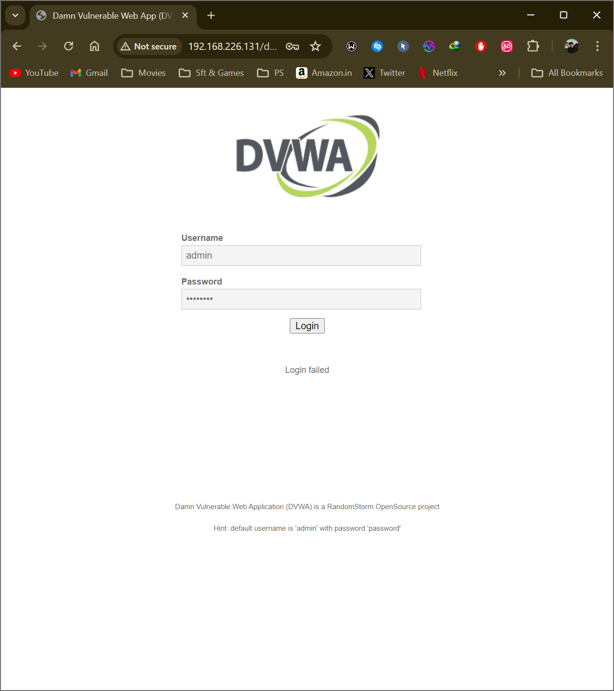

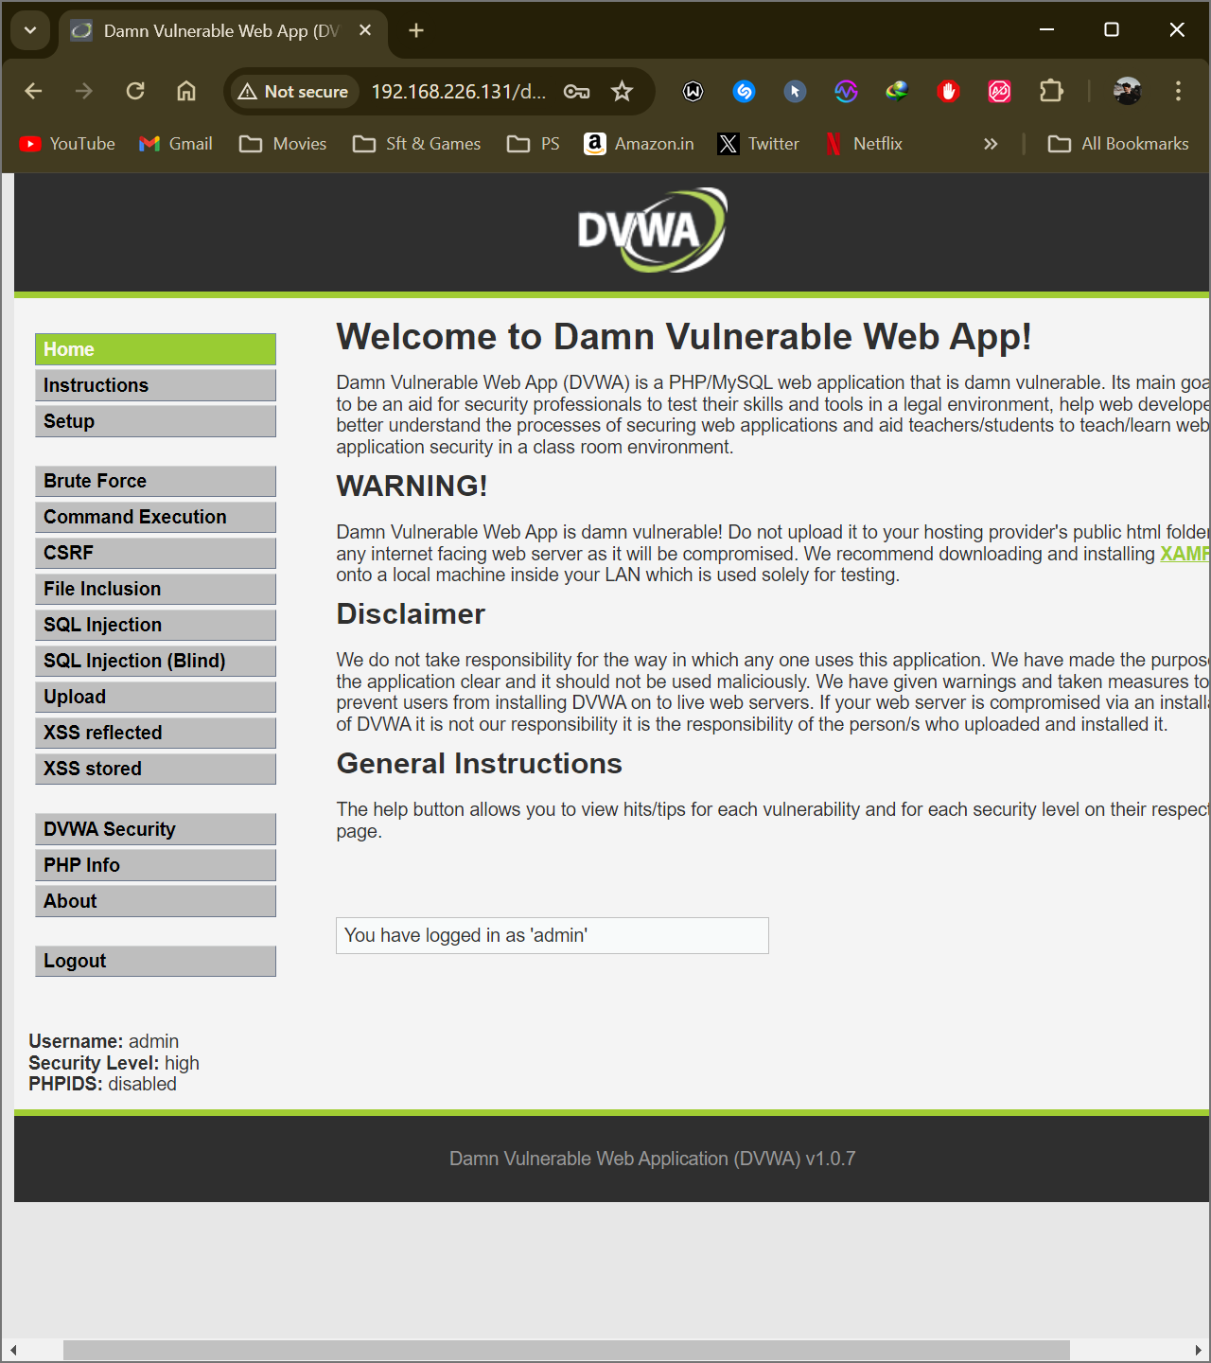

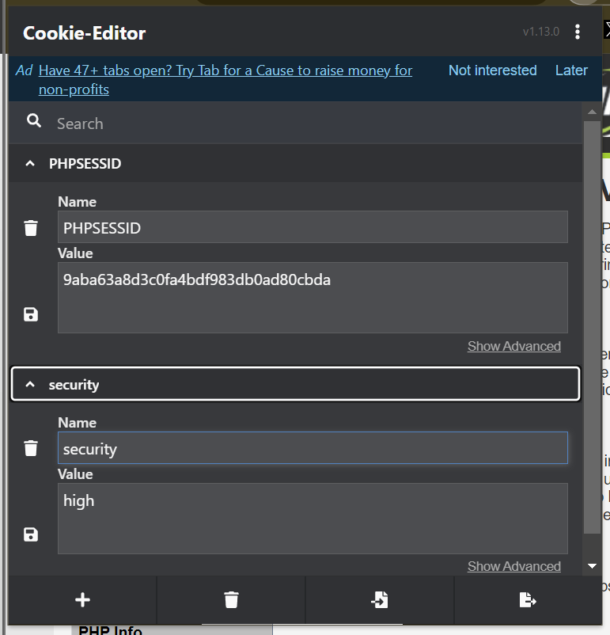

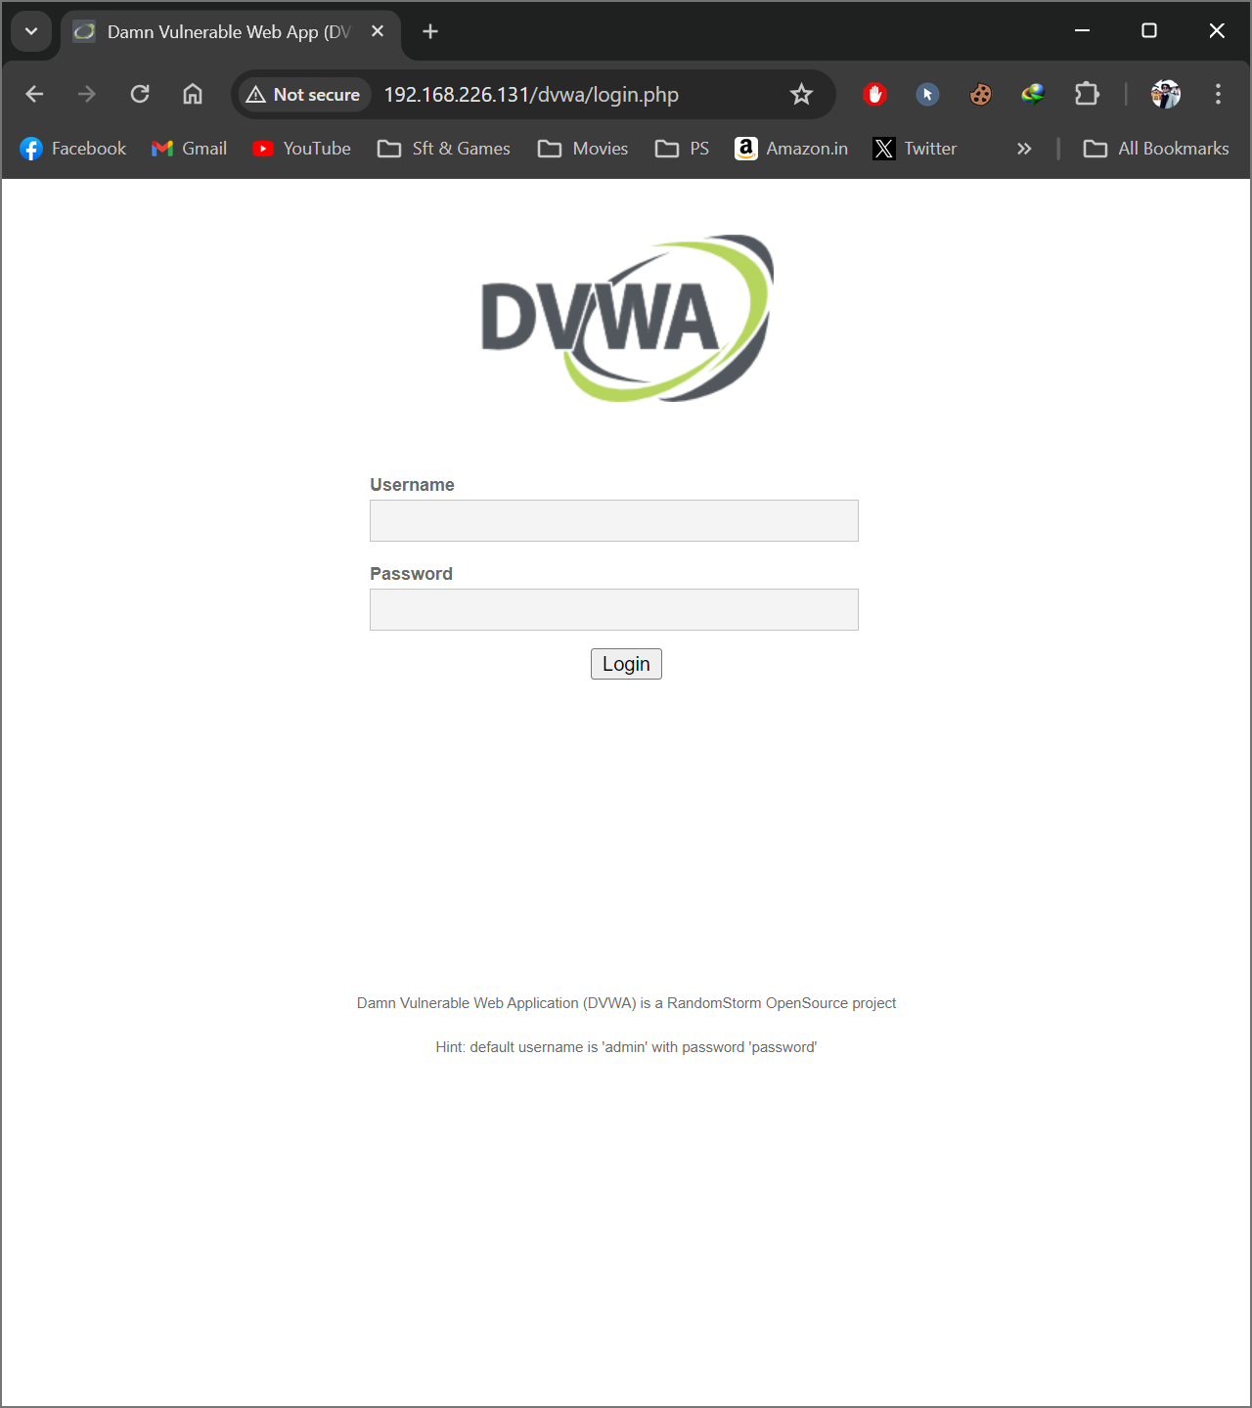

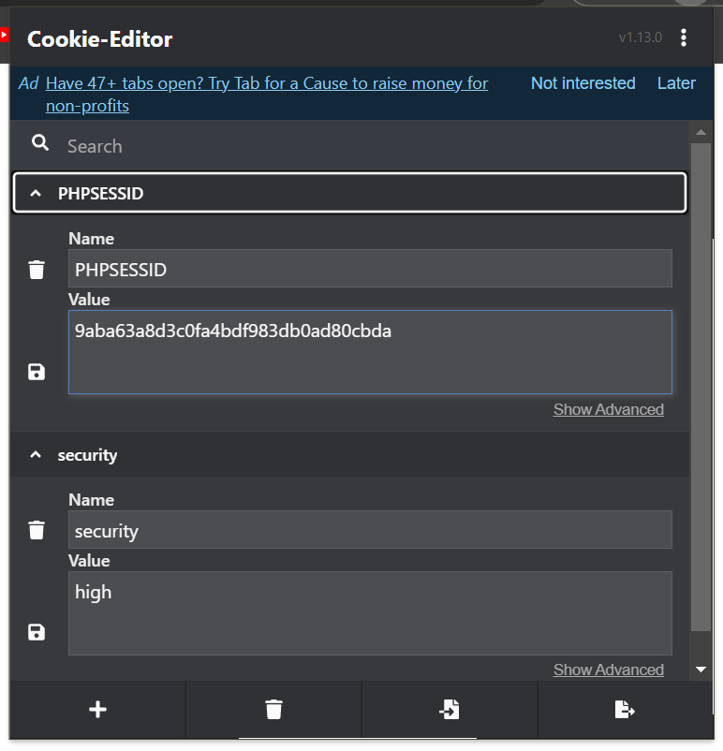

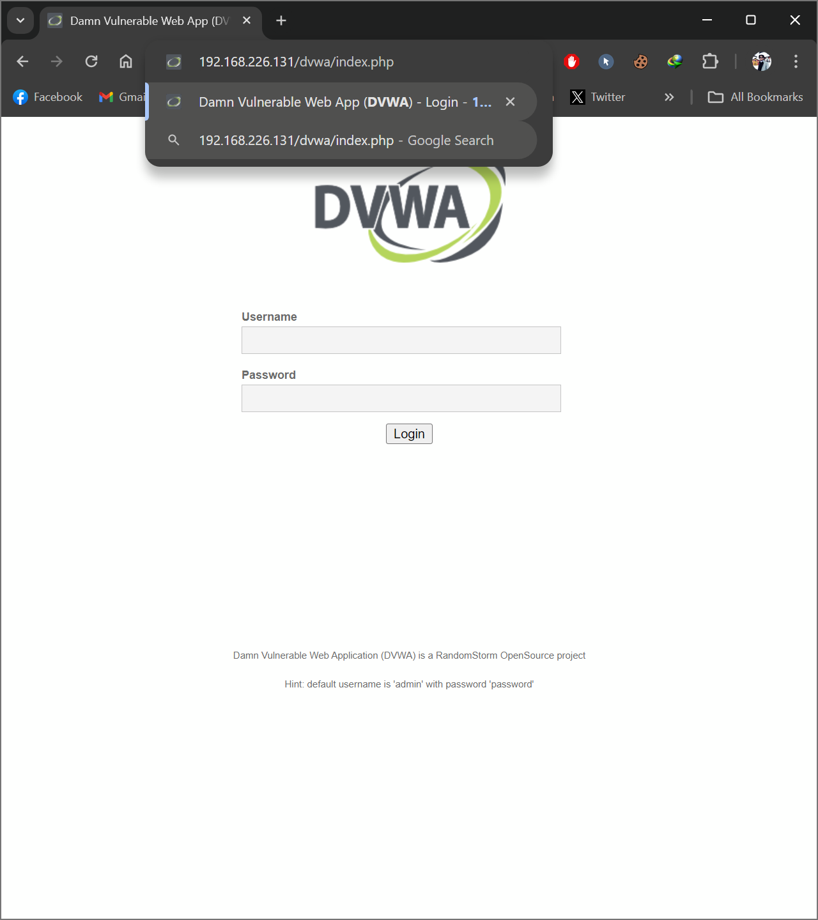

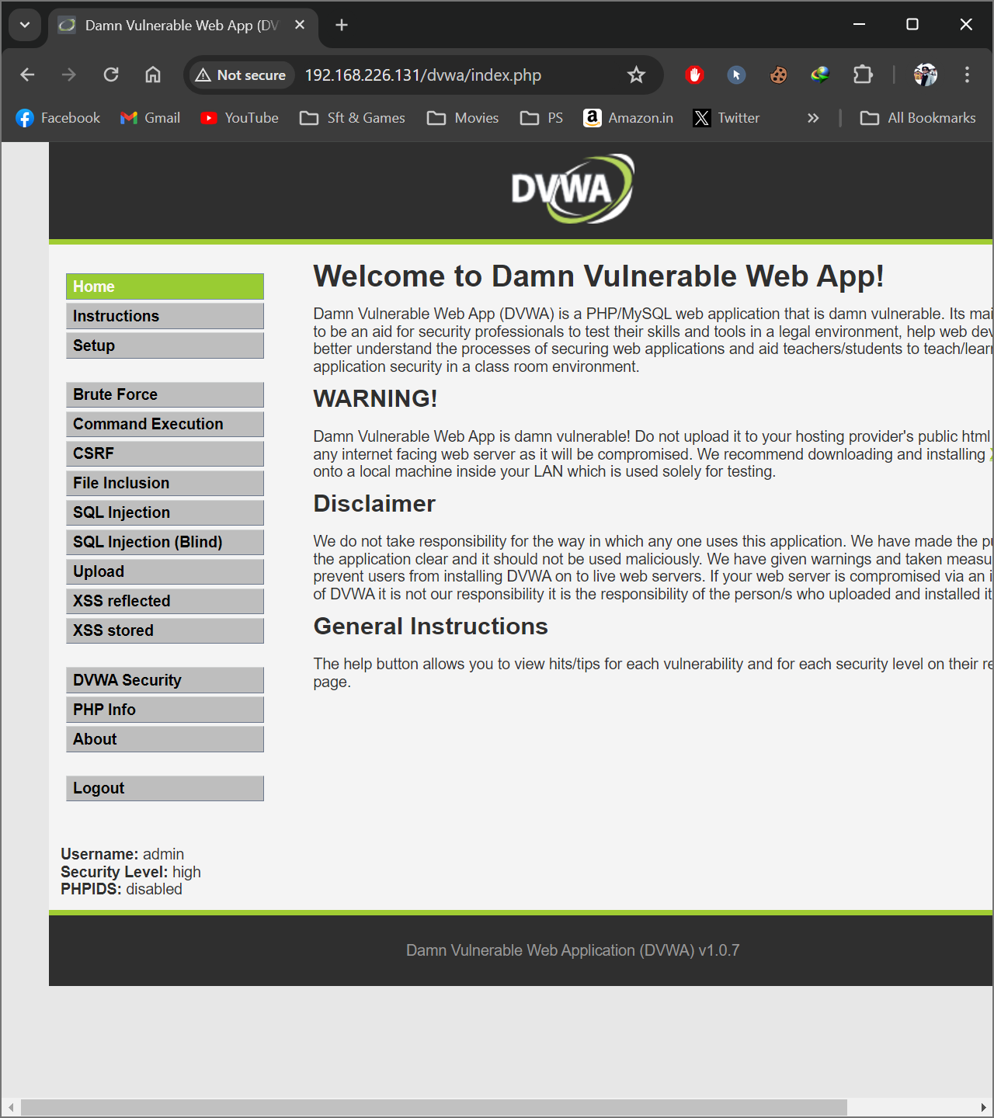

__________________

**Tested On demo.testfire**

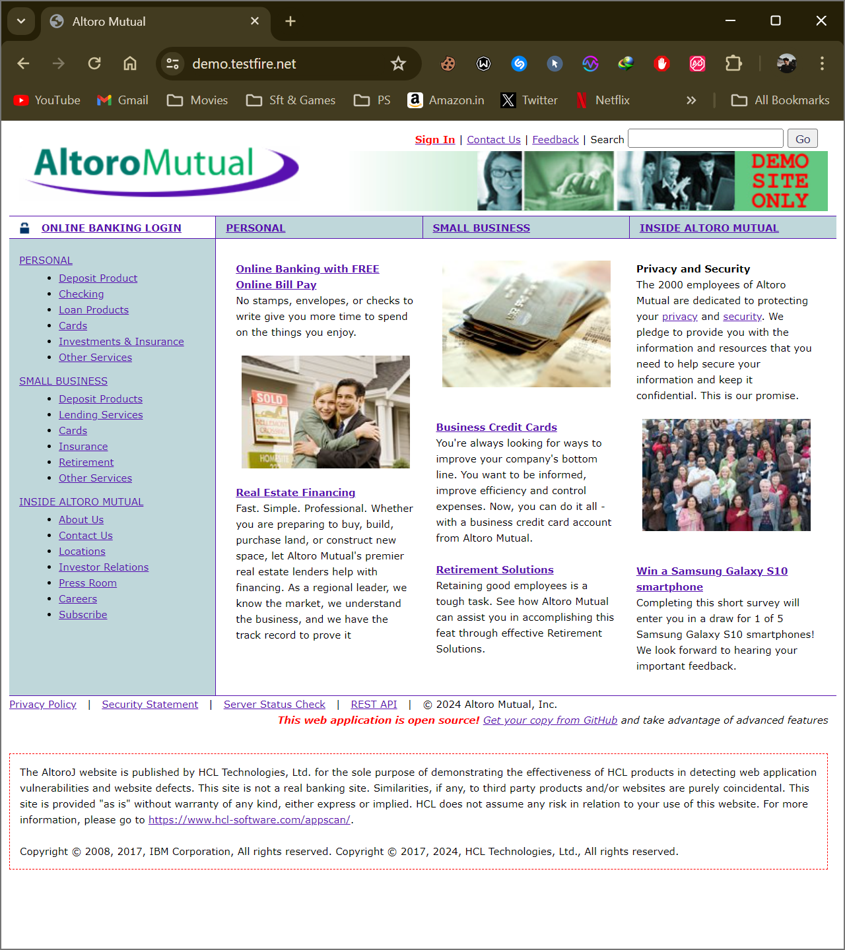

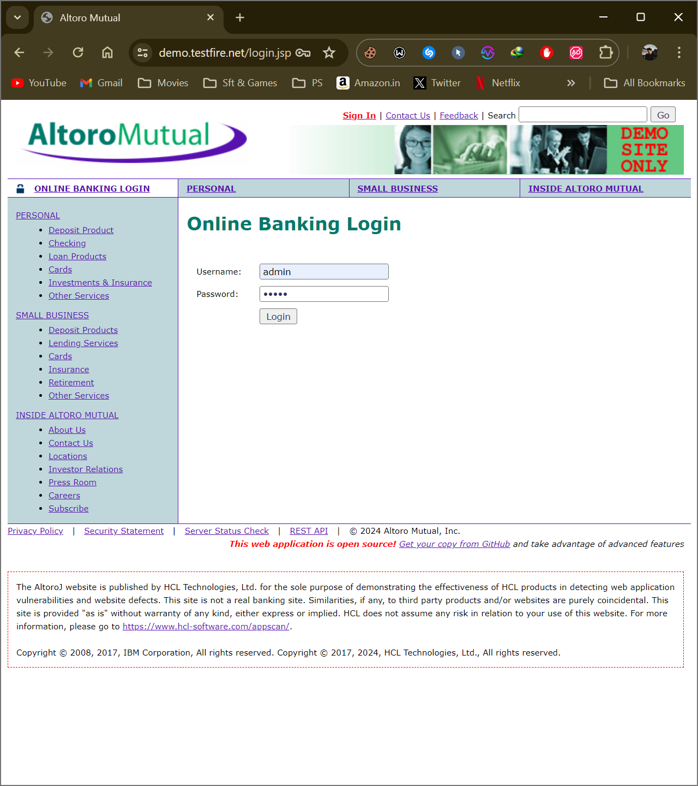

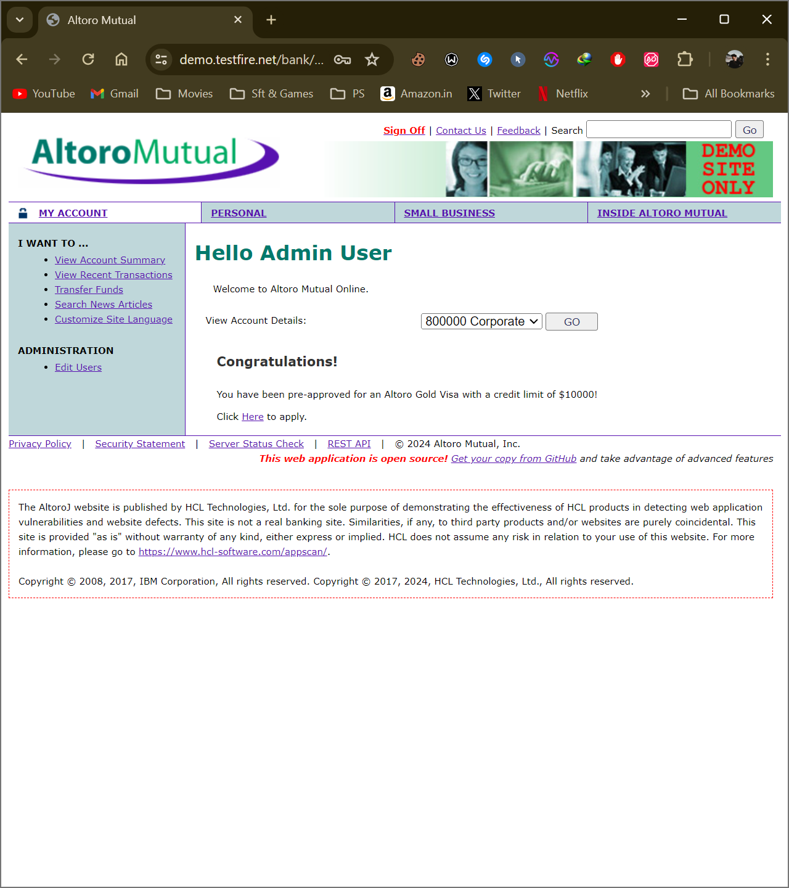

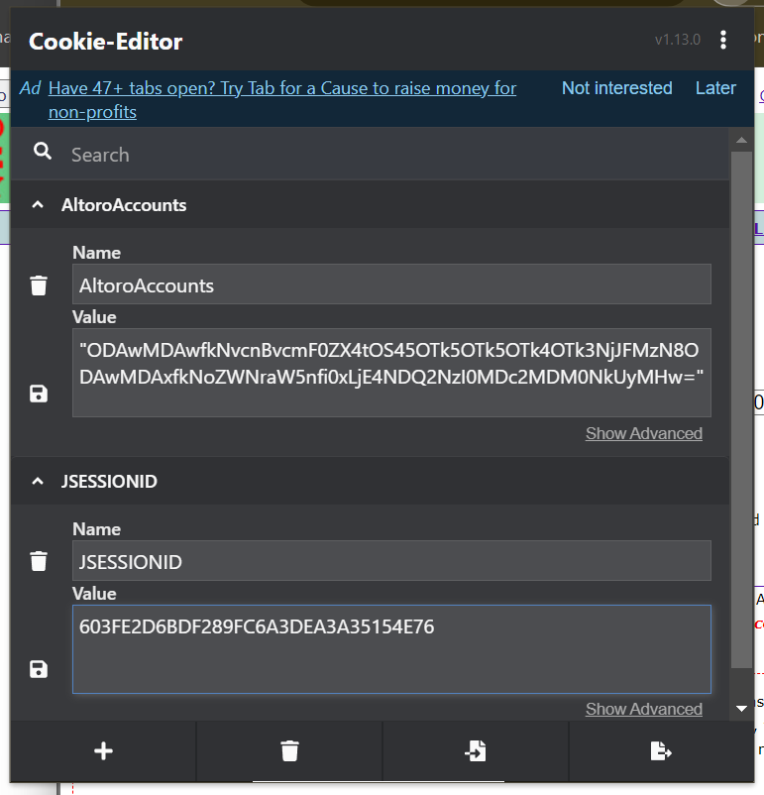

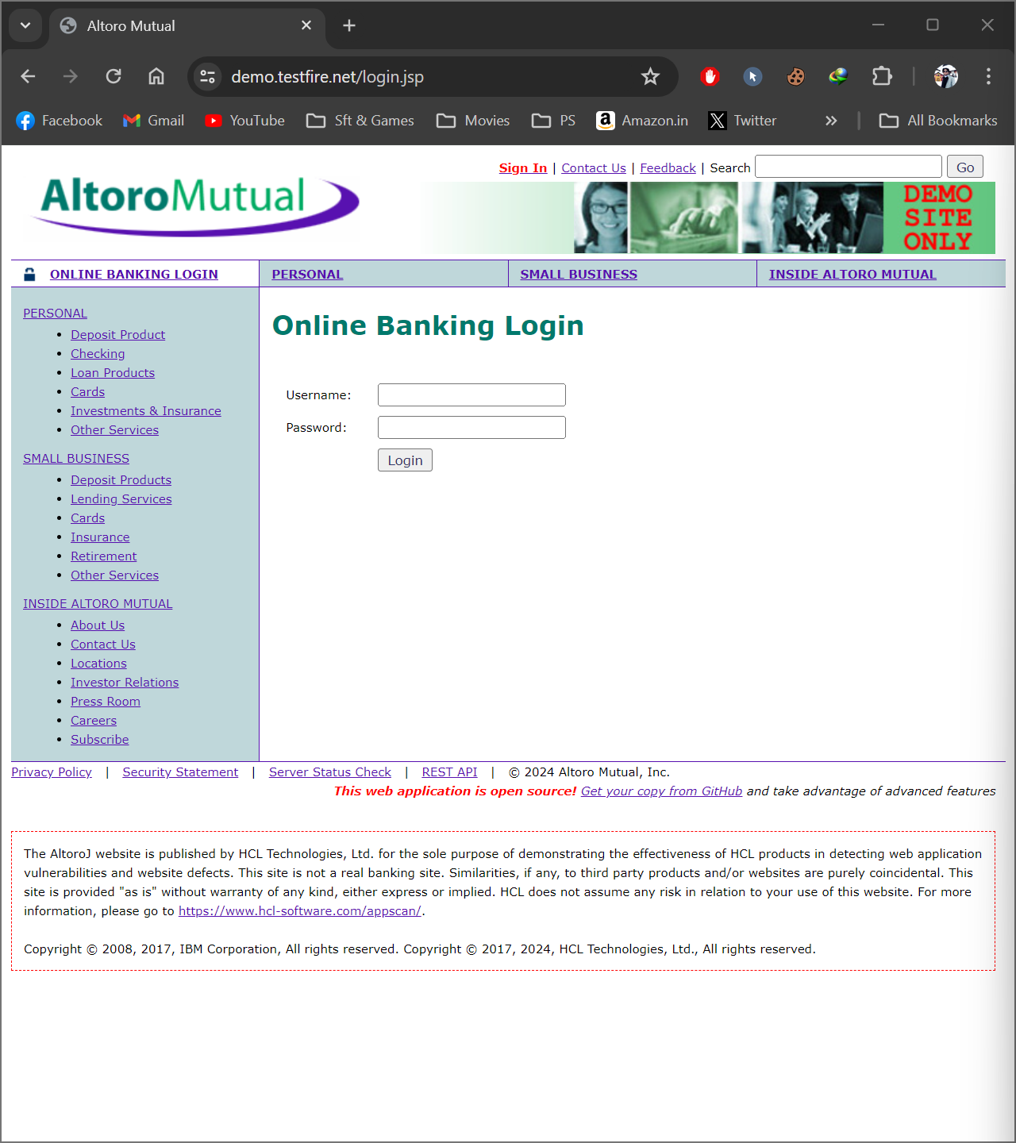

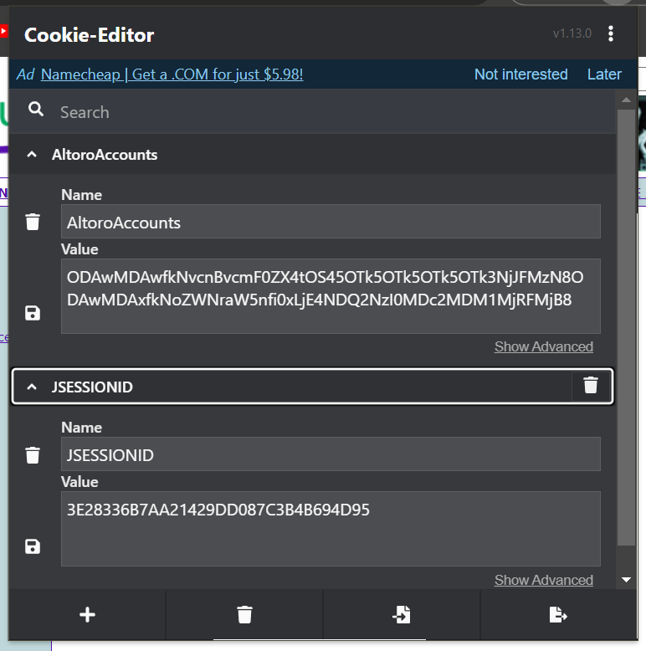

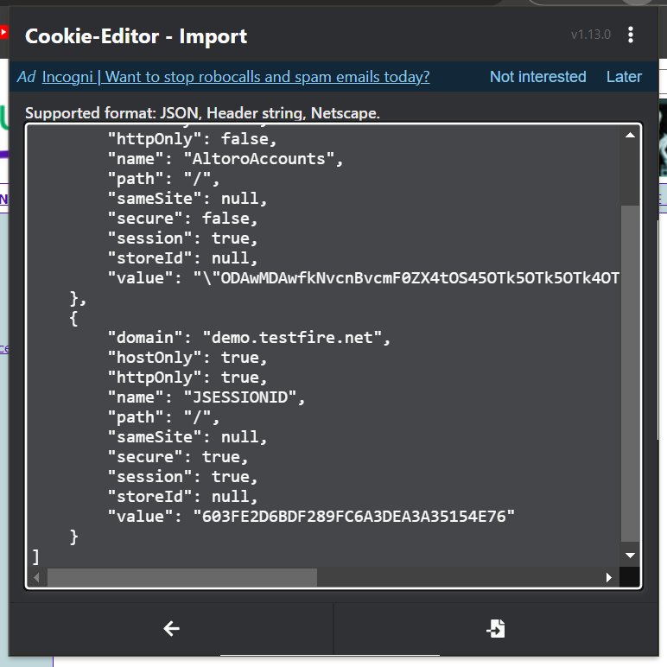

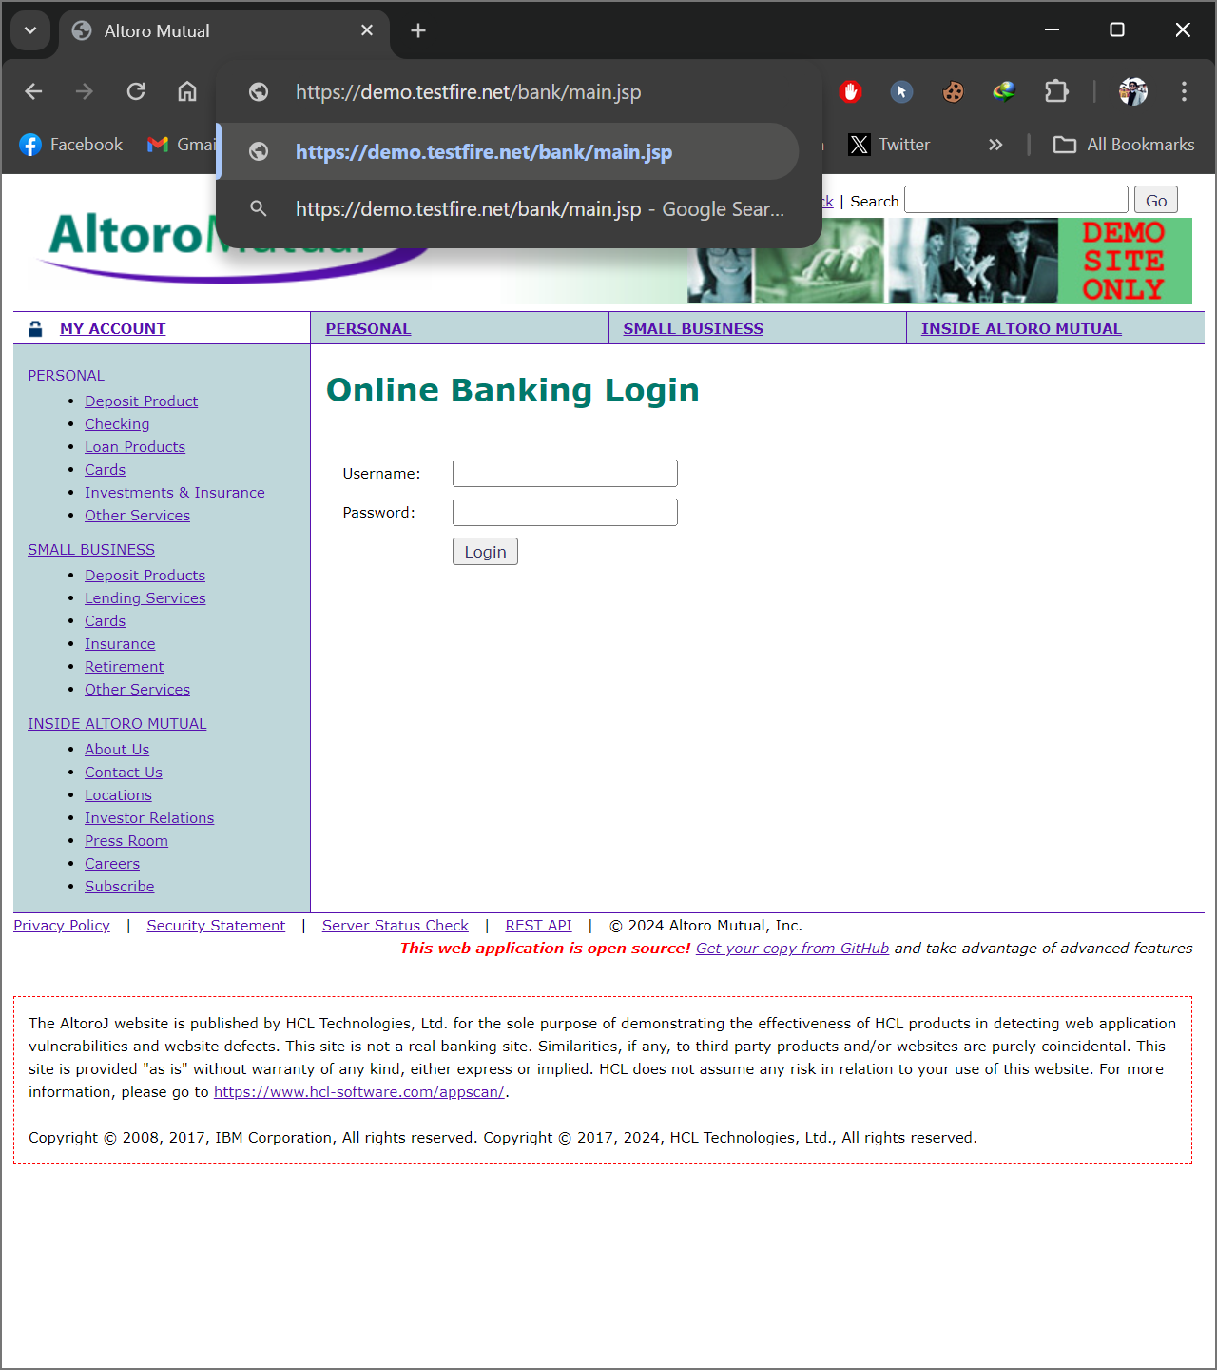

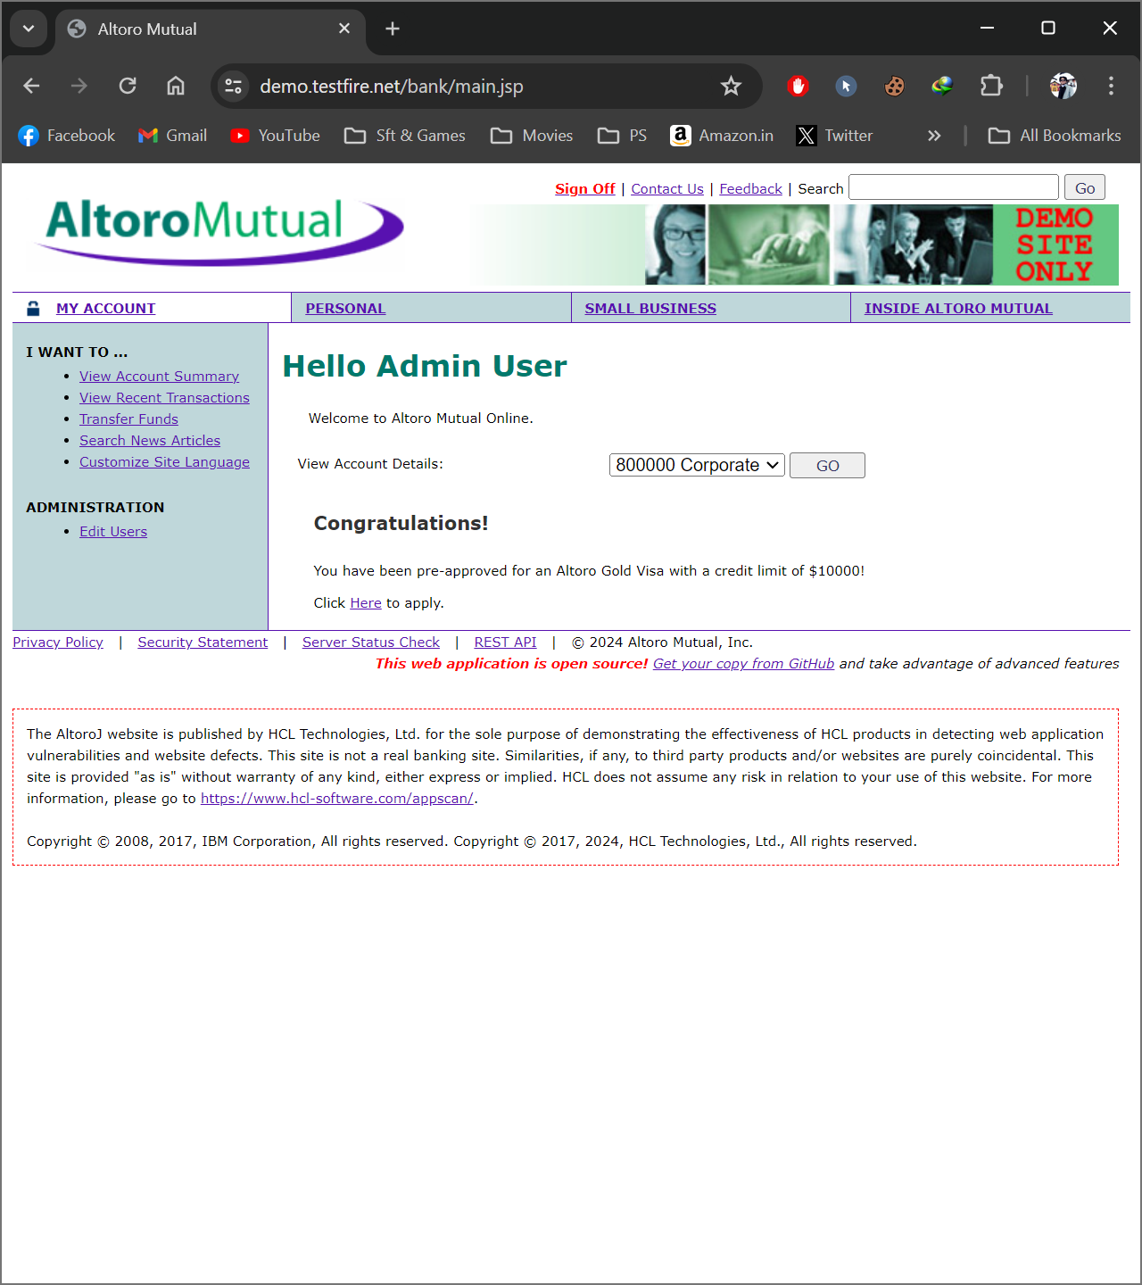

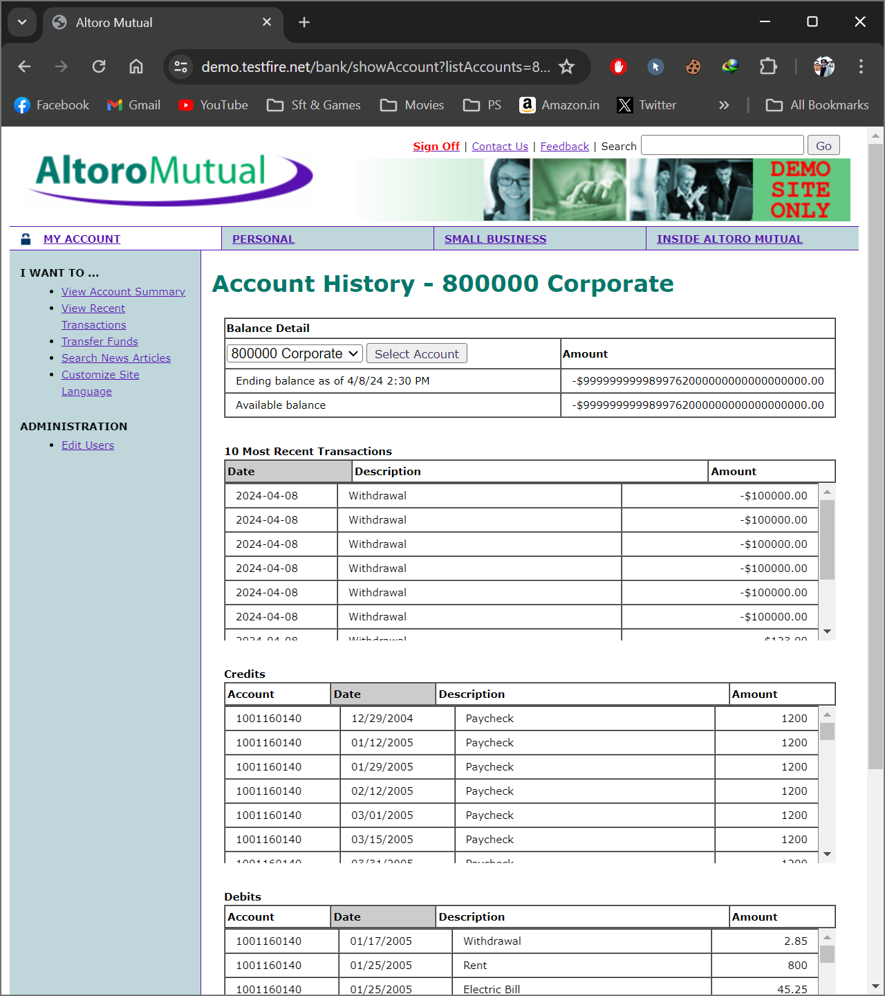

__________________

**Tested On vulnweb.com**

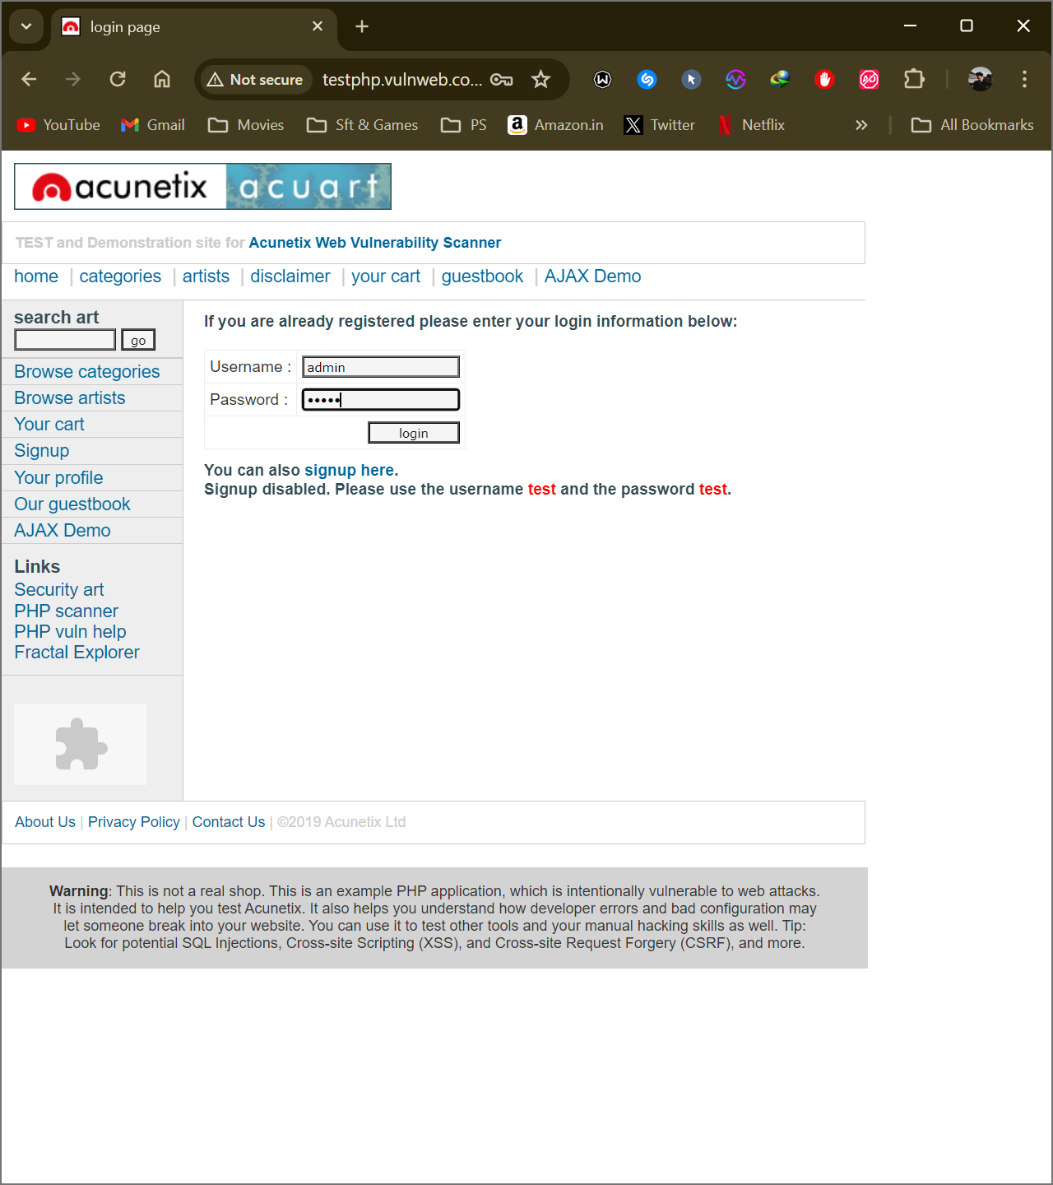

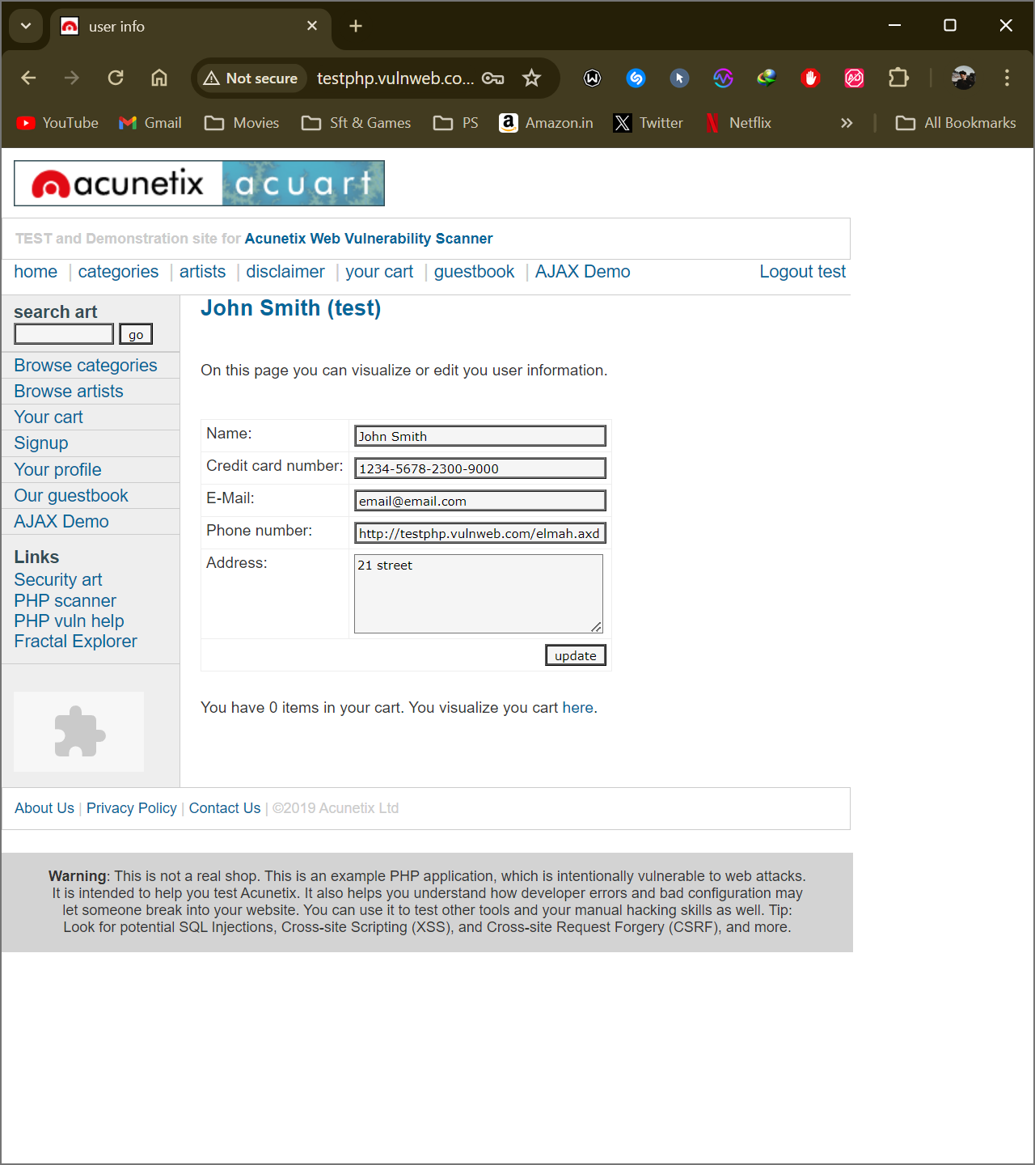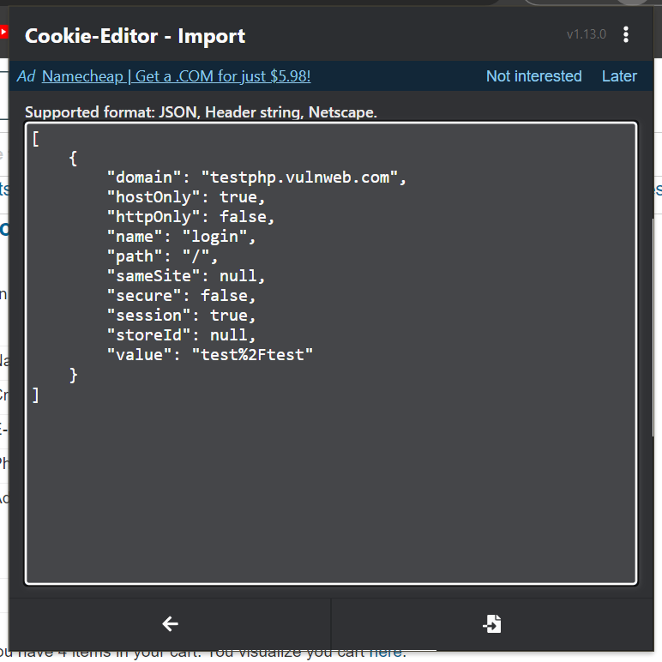

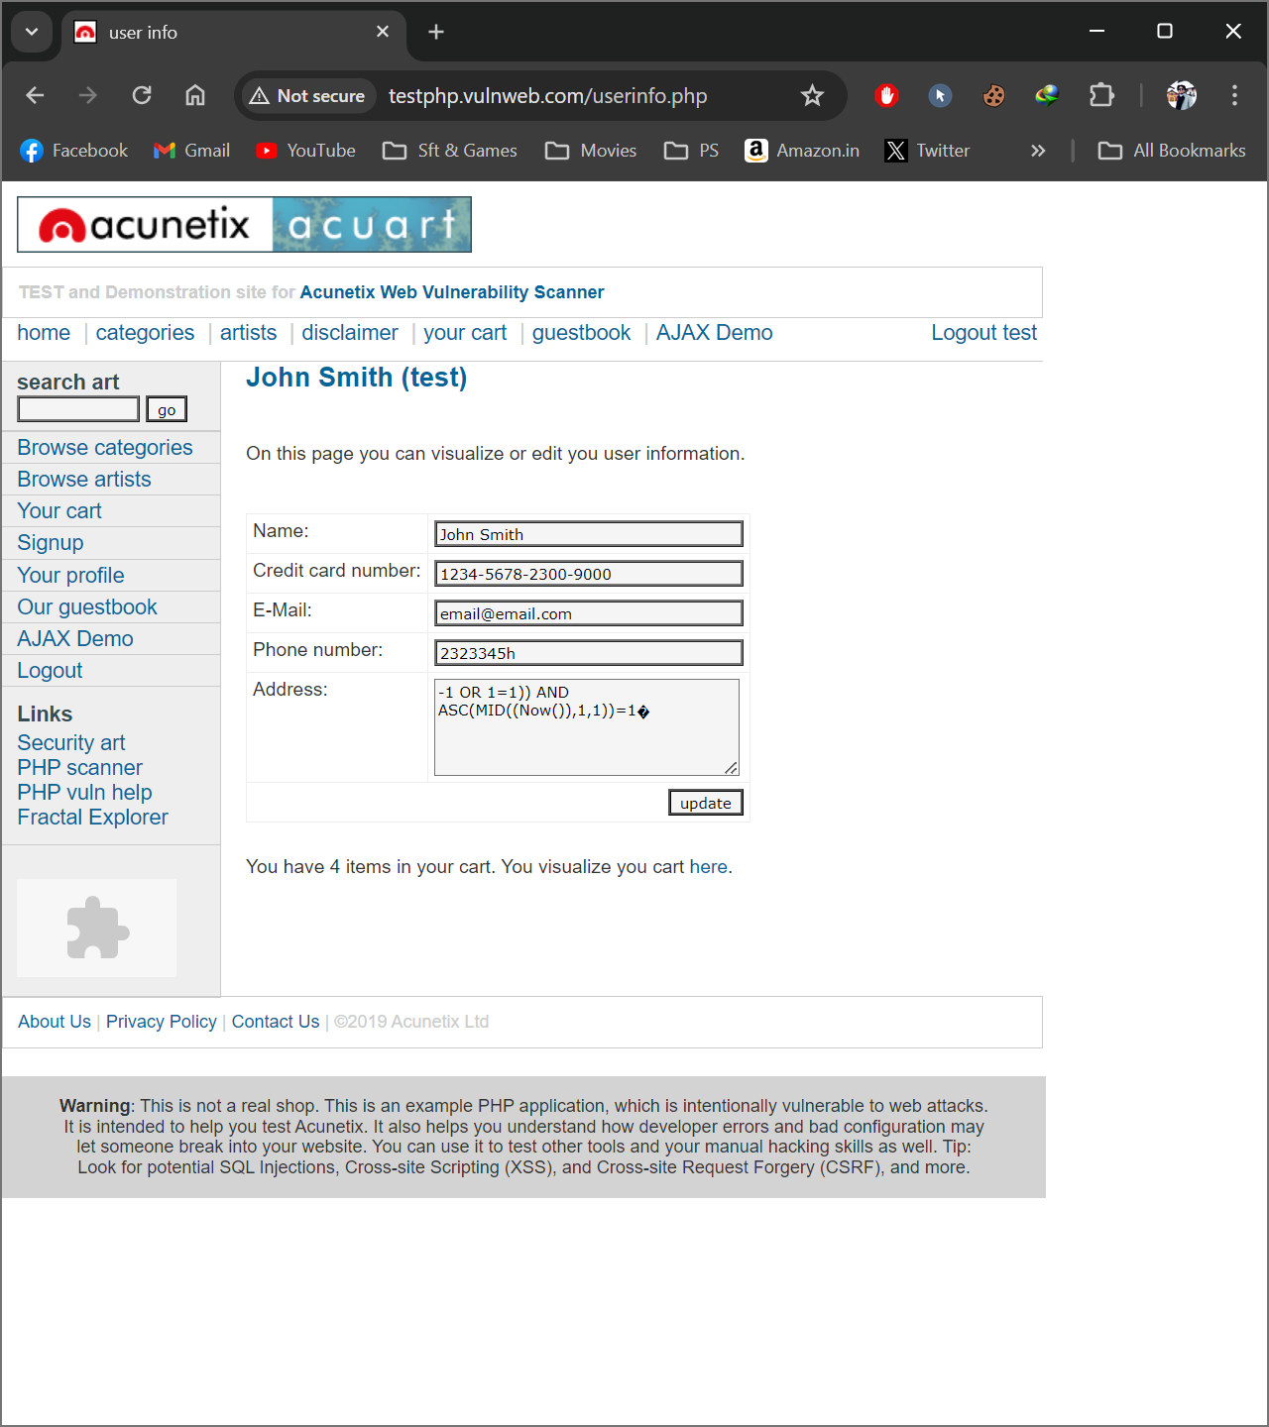

__________________

**Tested On Canva.com**

***Victim Browser from where cookies to be copied.***

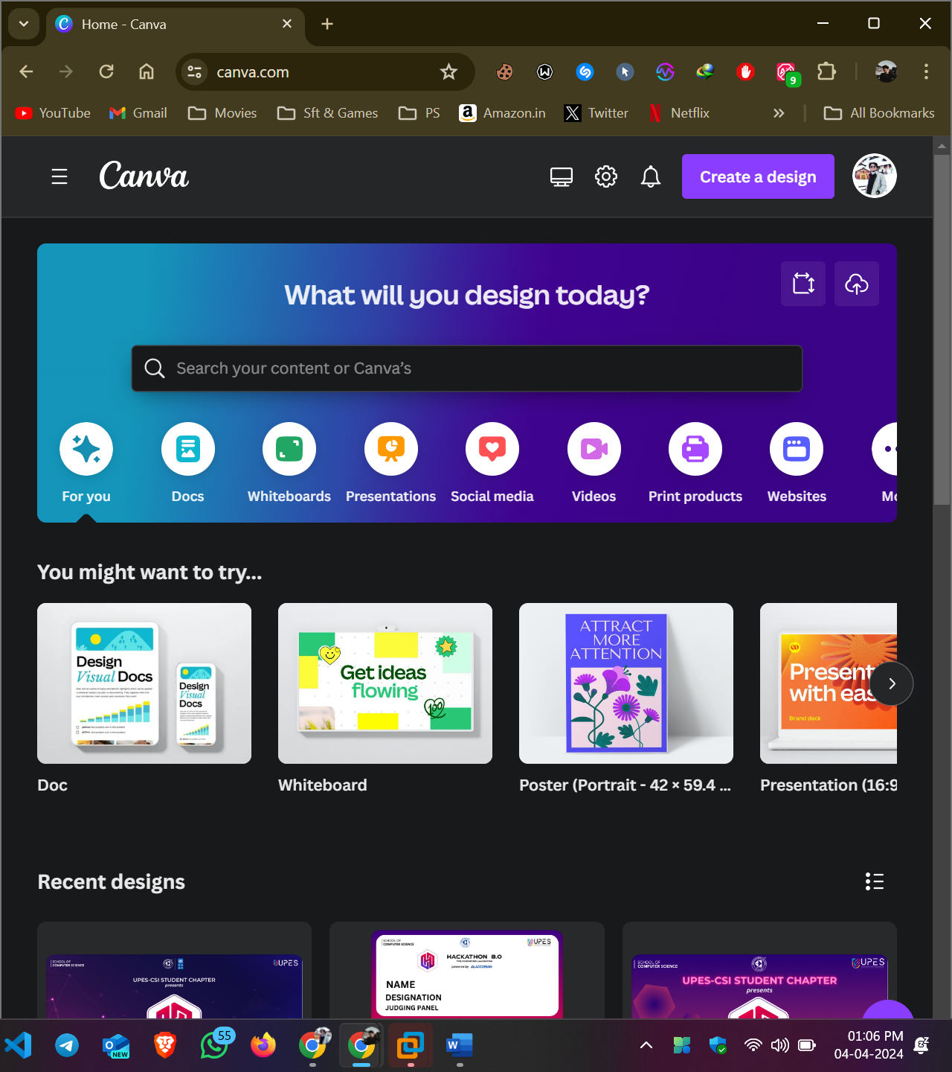

***Hijacker’s Browser where the cookies have to be injected.***

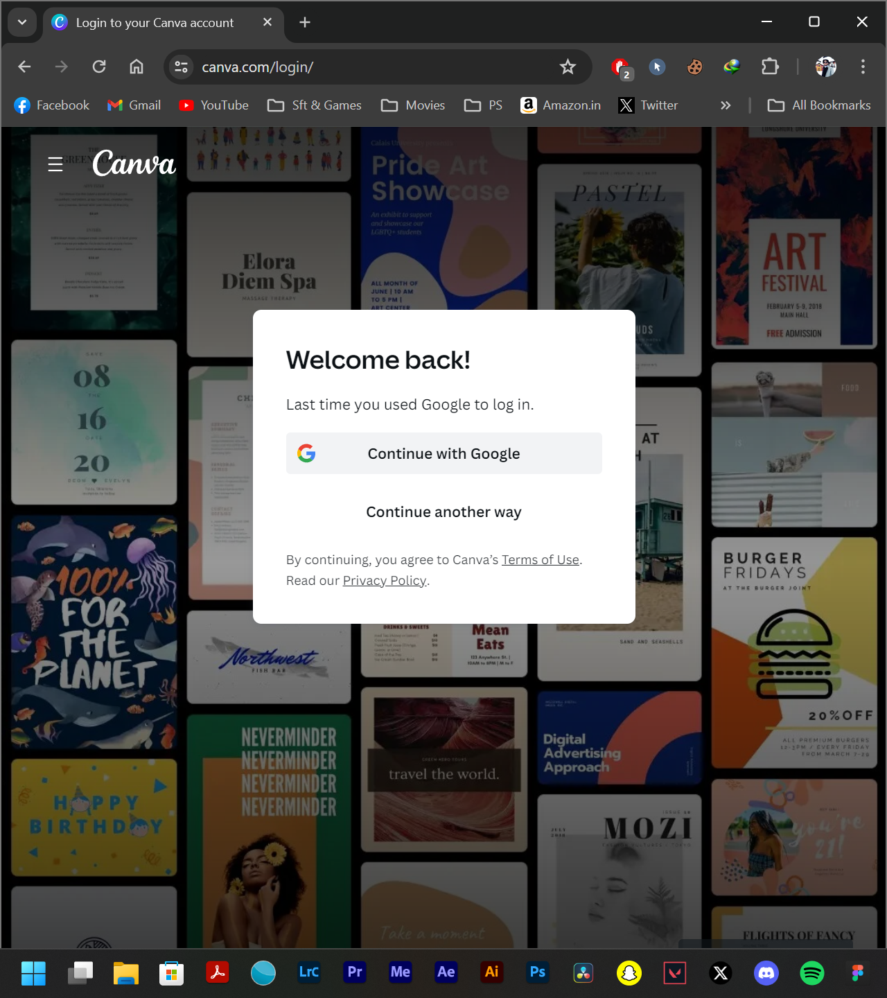

***Cookie Editor is a plugin of Chrome browser which is used to export and import the cookies of specific website. Hence, the image shows you the plugin of the chrome browser.***

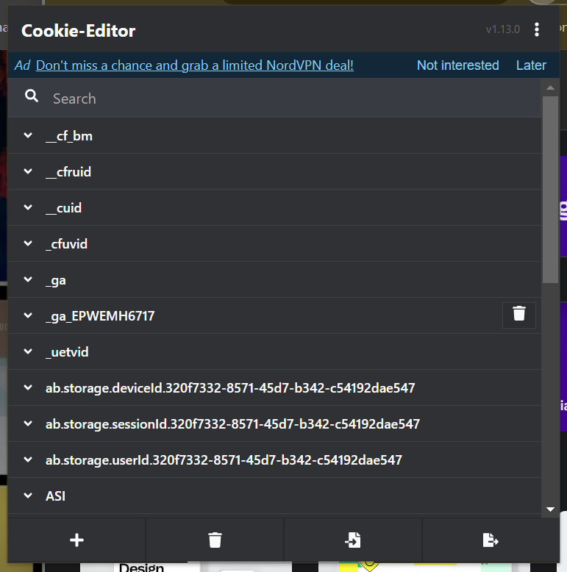

***To share the cookies from the Victim’s Browser, export the cookies from the browser by installing the plugin namely Cookie – Editor.***

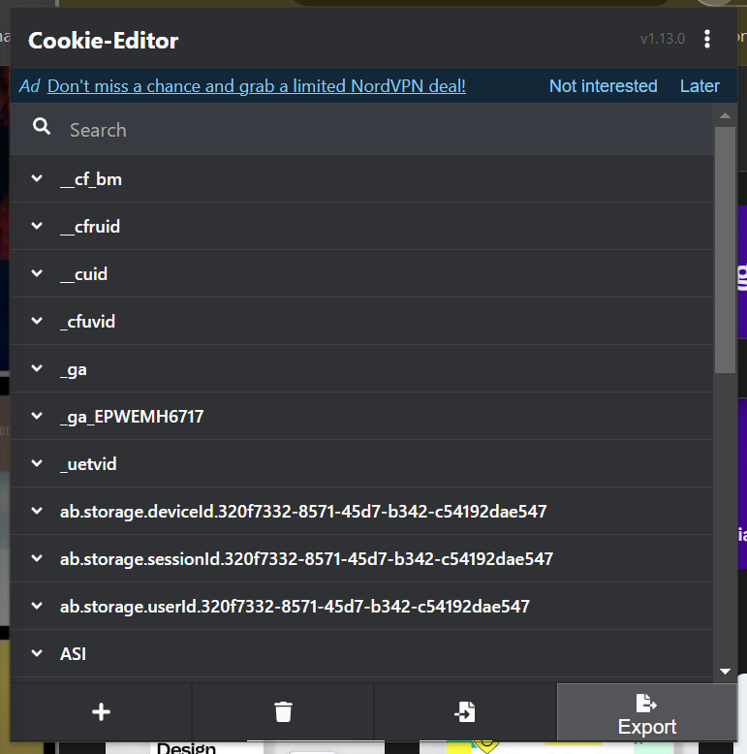

***Export the cookies in the JSON format so that it would make your work easier to import into your browser.***

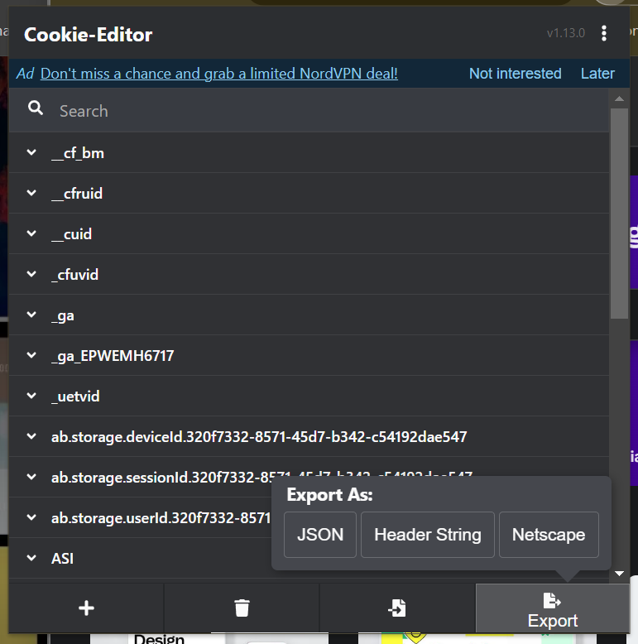

***Hence on clicking the export button the cookies will be copied to the victim’s device’ clipboard and you can share those cookies that is in text format.***

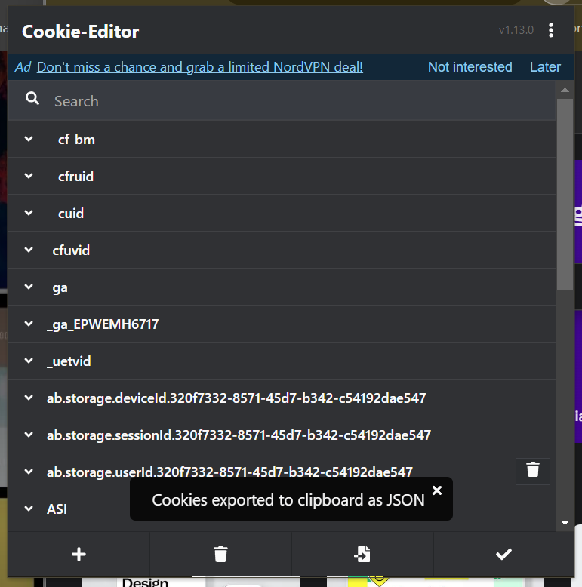

***Now go for your browser’s Cookie-Editor plugin and you can see the cookies for your website.***

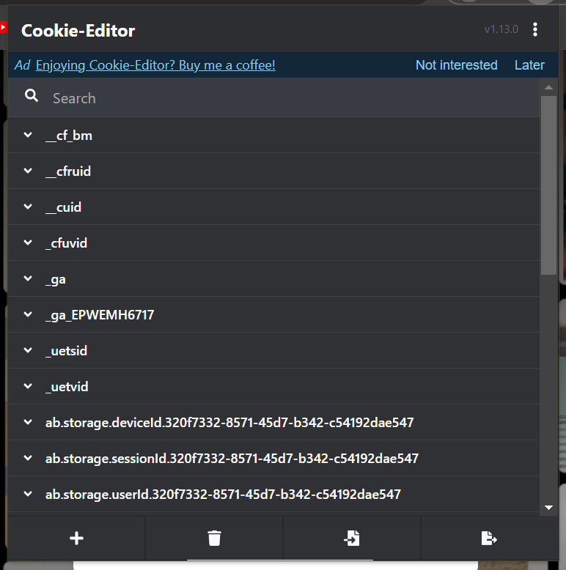

***Delete all of your browser’s cookies for that specific website of which you copied the cookies of.***

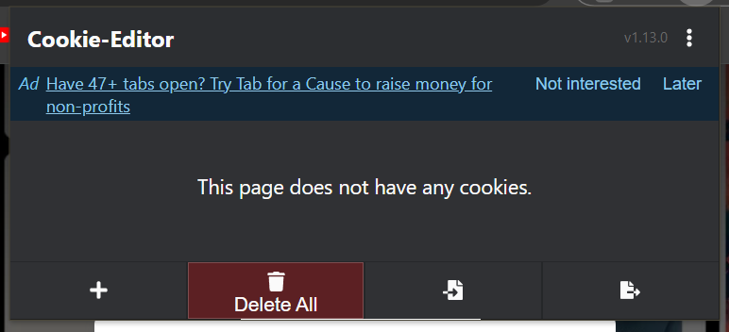

***Click for the Import option to import the victim’s cookies to your system.***

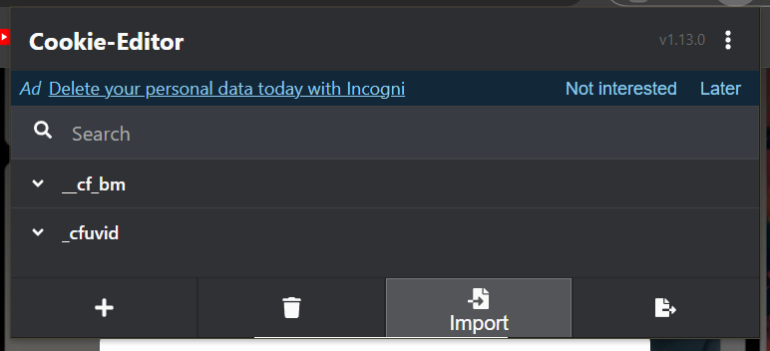

***Hence you will able to see the editor terminal for importing the cookies.***

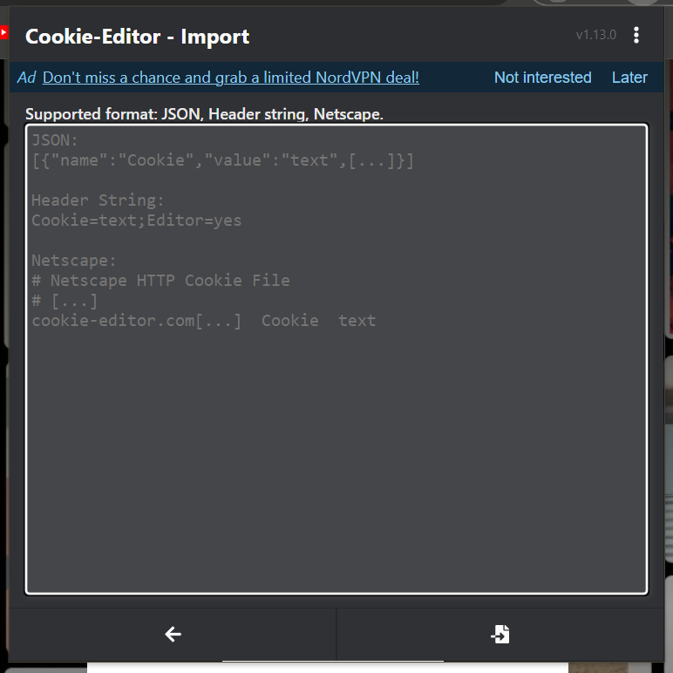

***Paste all the cookies data to your browser’s cookie editor terminal and hence it would look similar to the image shown below.***

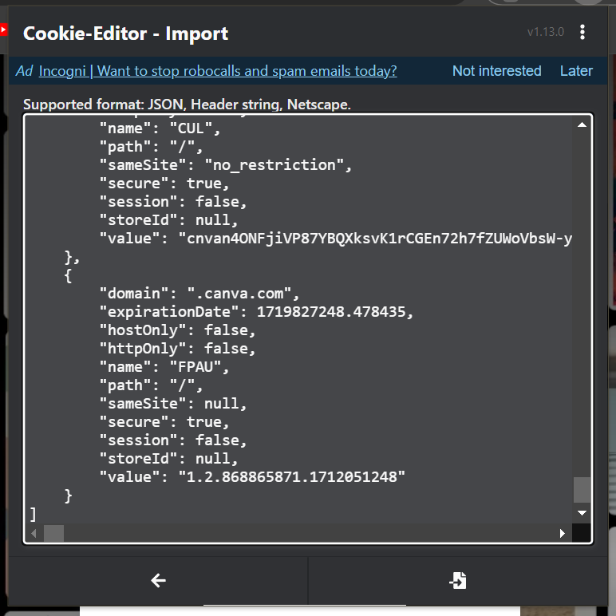

***Hene on clicking import again the cookies will get imported or overwritten on your browser’s cookie editor.***

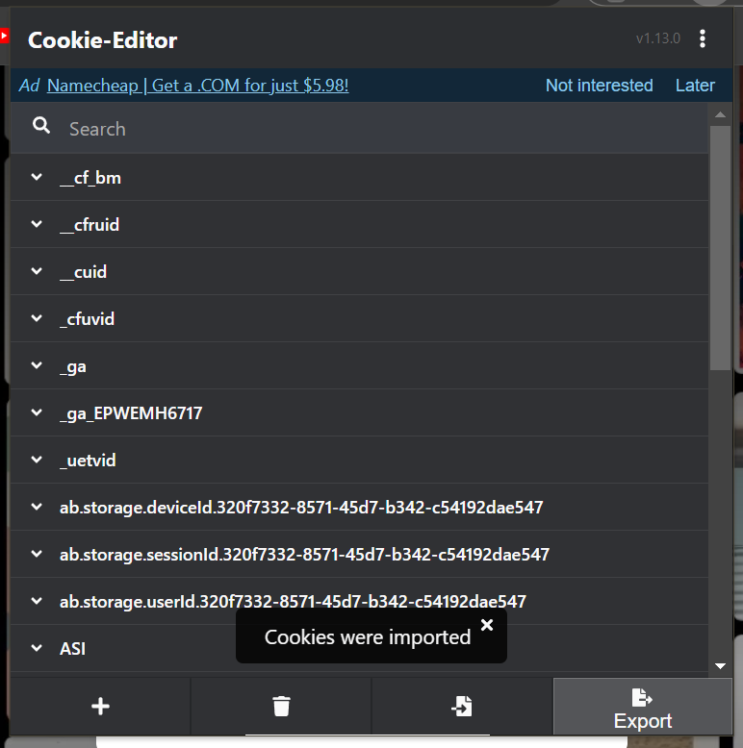

***Boom! Reload the webpage and you can easily able to see the logged in account of the victim on your device without his permission and login credentials and you can do whatever you feel like.***

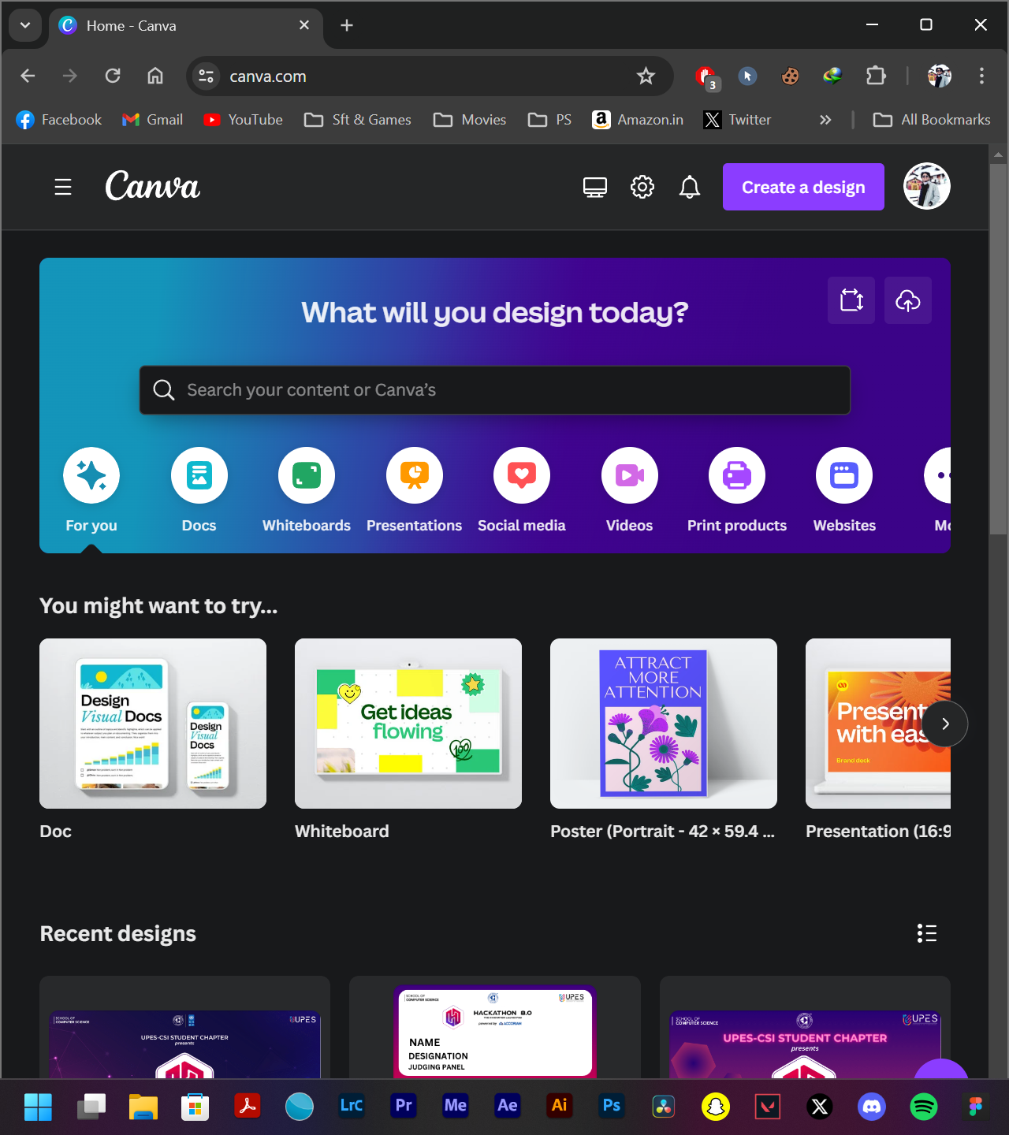

**Report on COUNTERMEASURES**

***How do you secure your session IDs and cookies?***

To protect your web app users from session hijacking and cookie stealing, it is important to secure your session IDs and cookies. This can be done by generating random and unpredictable session IDs, setting short expiration times for the session IDs, using HTTPS for all web app communications, setting secure and http-only flags for cookies, setting same-site flags for cookies, and implementing anti-CSRF tokens or headers. Additionally, session IDs should be invalidated when the user logs out or when the session is idle. Doing this will help verify the origin and integrity of the requests to your web app.

* **Supplement this with Device Trust and IP address-based controls to further secure** how and where admins can sign into the OneLogin platform.  Supplement this with Device Trust and IP address-based controls to further secure how and where admins can sign into the OneLogin platform.
* **Enable custom email notifications to be sent to users when privileged activities have been performed on your OneLogin environment from their respective admin user accounts.** If users receive email notifications indicating activities performed which they do not recognize, they can immediately alert your security team to investigate and respond accordingly.



***Use multi-factor authentication***

Another effective way to prevent cookie stealing is to use multi-factor authentication (MFA) for your web app. MFA requires users to provide more than one piece of evidence to prove their identity, such as a password, a code, a token, or a biometric factor. This adds an extra layer of security to your web app, and makes it harder for attackers to access your users' accounts with just a stolen cookie.

***Use secure and HTTP-only cookies***

The first step to prevent cookie stealing is to use secure and HTTP-only flags on your cookies. Secure cookies ensure that they are only sent over encrypted HTTPS connections, preventing attackers from intercepting them on unsecured networks. HTTP-only cookies prevent JavaScript code from accessing them, preventing attackers from exploiting cross-site scripting (XSS) vulnerabilities to steal them.

***How do you monitor and respond to these threats?***

Protecting your web app users from session hijacking and cookie stealing requires monitoring and responding to these threats. Logging and auditing web app activities, such as user logins, sessions, requests, errors, and anomalies can help. Additionally, alerts and notifications should be implemented for any suspicious or malicious events. Patches and updates should be applied to web app components, frameworks, libraries, and dependencies to fix any known vulnerabilities or bugs. Security tests and assessments such as penetration testing, vulnerability scanning, or code review should be conducted regularly to identify and resolve any security issues or weaknesses. Lastly, a security incident response plan should be developed and followed in order to contain, analyze, report, and recover from any session hijacking or cookie stealing attacks.